# Place the Title of Your Paper Here

Author A.1,* and Author B.2

1Department of Estate Management, Faculty of Environmental Sciences, University of Benin, Benin City, Edo State, Nigeria

2Department of Civil Engineering, Faculty of Engineering, University of Benin, Benin City, Edo State, Nigeria

Corresponding Author: *author.a@uniben.edu

https://doi.org/10.36263/nijest.xxxx.xx.xxxx

|  |
| --- |
| **ABSTRACT**  *The abstract should be a single paragraph of not more than 300 words and summarizes the content of the paper. At the end of the abstract, 5 – 7 keywords should be provided for indexing purpose. The abstract should be a single paragraph of not more than 300 words and summarizes the content of the paper. At the end of the abstract, 5 – 7 keywords should be provided for indexing purpose. The abstract should be a single paragraph of not more than 300 words and summarizes the content of the paper. At the end of the abstract, 5 – 7 keywords should be provided for indexing purpose. The abstract should be a single paragraph of not more than 300 words and summarizes the content of the paper. At the end of the abstract, 5 – 7 keywords should be provided for indexing purpose. The abstract should be a single paragraph of not more than 300 words and summarizes the content of the paper. At the end of the abstract, 5 – 7 keywords should be provided for indexing purpose. The abstract should be a single paragraph of not more than 300 words and summarizes the content of the paper. At the end of the abstract, 5 – 7 keywords should be provided for indexing purpose.*  **Keywords:** Keyword1, Keyword2, Keyword3, Keyword4, Keyword5 |

## 1.0. Introduction

Submission of a paper to NIJESTimplies that the corresponding author has obtained the permission of all authors, and that all authors have read the paper and guarantee that the paper is an original research work, that the data used in carrying the research will be provided to NIJEST Editors if requested, and that the paper has not been previously published and is not currently under review for publication by another journal.

The Corresponding Author is responsible for ensuring that all figures, tables, text, and supporting materials are properly cited and, when necessary, obtaining permission for reprinting copyrighted material. Submit your manuscript as an attached file to the email address: [editor-in-chief@nijest.com](mailto:editor-in-chief@nijest.com). Please read through the following as guidelines to preparing your final manuscript for submission.

When writing author affiliations, do not abbreviate institution names or use designations such as MBA, CPA or Ph.D. When writing paper title, use font size 16, Bold, Centred, Times New Roman. When writing authors name and affiliations, use font size 12, Centred, Times New Roman. For main headings e.g. Introduction, use font size 11, Bold, Times New Roman. For sub headings, use font size 11, Times New Roman (Author, 2019).

For document text (body of paper), use font size 11, justified, Times New Roman. For text within tables, use font size 9, Times New Roman. For notes to tables, use font size 9, italic, Times New Roman. For Tables and Figures caption, use font size 11, Times New Roman. Captions for Tables should be written above the Table, while Captions for Figures should be written below the Figures. Numberings should start from 1 and continue in an ascending order and in order of appearance (Author, 2018; Nijest *et al*., 2019). For text within figures, use font size 9, Arial. The use of acronyms is allowed everywhere in the paper EXCEPT in the title or abstract. Acronyms should be defined when fist used in the paper.

## 2.0. Methodology

### 2.1. Materials

Place tables in the text as you wish them to appear and in conjunction with the corresponding discussion. Tables must include a title and be numbered consecutively as “Table 1: Description” and so forth. The title must appear outside the table. Titles for tables should be in title case in a Times New Roman Font of 11. Tables must be black and white only. Do not use colour in tables. Define all variables in your table within the table or in the note to the table and in the text of the document.

Place figures in the text as you wish them to appear and in conjunction with the corresponding discussion. Figures must be numbered consecutively as “Figure 1: Description” and so forth. Use the word “Figure” as the label. Titles for figures should be separate from the figure itself and in title case, in a Times New Roman Font of 11. Use an Arial font of 8 for text within figures.

Create Equations using the Microsoft Word Equation Tool. Number equations consecutively on the right margin. For example:

$y=A+Bx_{1}+Cx_{2}+Dx_{3}$ (1)

**Table 1:** Caption of table

|  |  |  |
| --- | --- | --- |
| **Variable** | **Size** | **Percentage (%)** |
| Variable A | 30 | 20 |
| Variable B | 30 | 20 |
| Variable C | 30 | 20 |
| Variable D | 30 | 20 |
| Variable E | 30 | 20 |

*A, B, C, D, E are variables*

### 2.2. Methods

Place tables in the text as you wish them to appear and in conjunction with the corresponding discussion. Tables must include a title and be numbered consecutively as “Table 1: Description” and so forth. The title must appear outside the table. Titles for tables should be in title case in a Times New Roman Font of 11. Tables must be black and white only. Do not use colour in tables. Define all variables in your table within the table or in the note to the table and in the text of the document.

Place figures in the text as you wish them to appear and in conjunction with the corresponding discussion. Figures must be numbered consecutively as “Figure 1: Description” and so forth. Use the word “Figure” as the label. Titles for figures should be separate from the figure itself and in title case, in a Times New Roman Font of 11. Use an Arial font of 8 for text within figures.

## 3.0. Results and Discussion

### 3.1. Subheading one

All reference works cited in the paper must appear in a list of references that follow the formatting requirements of NIJEST given below. References not cited should not be listed. Citing and Listing of references should be according to the following:

Citing references in the body of the paper:

1. For citations with one author, include author’s name and year e.g. (Osamuyi, 2016). For two authors, include both authors' names e.g. (Ehiorobo and Izinyon, 2015). For citations with three or more authors, list only the first author's name followed by *et al*. e.g. (Osamuyi *et al.,* 2014)
2. Cite references chronologically e.g. (Osamuyi *et al.* 2014; Ehiorobo and Iznyon, 2015; Osamuyi, 2016)

For multiple citations with the same first author, list single-author entries by year using 2014a, 2014b, etc. For example: (Osamuyi *et al.,* 1996a).

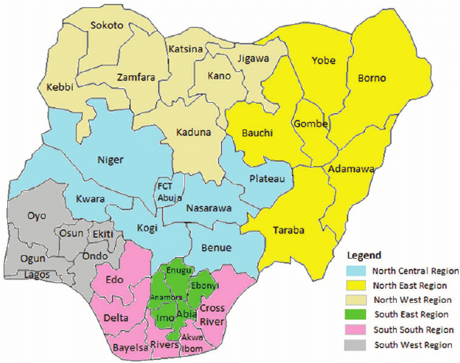

**Figure 1:** Caption of figure

### 3.2. Subheading two

In the reference section at the end of the document, include a single space between each reference. Do not indent references. For journal articles, be sure to include, author names, year of publication, article title, Journal Name, volume number, issue number and page numbers. References should appear according to the following:

1. List references with three or more authors only by year and without regard to number of authors or alphabetical rank of authors beyond the first. For example:

Izinyon, O.C., Ehiorobo, J.O. and Ogirigbo, O.R., (2014). L-moments approach for flood frequency analysis of river Okhuwan in Benin-Owena River basin in Nigeria. *Nigerian Journal of Technology*, 33(1), pp.10-19

1. For articles with more than five authors, list the first five names and then *et al*.
2. For multiple citations with the same first author published in the same year, list entries by year using 1996a, 1996b, etc. Alphabetize by second author.
3. Sample journal article citation:

Izinyon, O.C. and Ehiorobo, J.O., (2014). L-moments approach for flood frequency analysis of river Okhuwan in Benin-Owena River basin in Nigeria. *Nigerian Journal of Technology*, 33(1), pp.10-19

1. Sample book citation:

Bond, W.R., Smith, J.T., Brown, K.L. & George, M., (1996). *Management of small firms*, McGraw-Hill, Sydney.

1. Sample chapter-in-book citation:

Beadle, G. W., (1957). The role of the nucleus in heredity, pp. 3-22 in *The Chemical Basis of Heredity*, edited by W. D. McElroy and B. Glass. Johns Hopkins Press, Baltimore.

1. Sample website citation:

Ehiorobo, J. (2014). *Fire Safety Engineering*. [online] Engineering Safety. Available at: http://www.firesafetyengineering.com/ehiorobo [Accessed 12 Nov. 2016].

## 4.0. Conclusions

Conclusion should be written here. Conclusion should be written here. Conclusion should be written here. Conclusion should be written here. Conclusion should be written here. Conclusion should be written here. Conclusion should be written here. Conclusion should be written here. Conclusion should be written here. Conclusion should be written here. Conclusion should be written here. Conclusion should be written here.

Conclusion should be written here. Conclusion should be written here. Conclusion should be written here. Conclusion should be written here. Conclusion should be written here. Conclusion should be written here. Conclusion should be written here. Conclusion should be written here. Conclusion should be written here. Conclusion should be written here. Conclusion should be written here. Conclusion should be written here.

**References**

Beadle, G. W., (1957). The role of the nucleus in heredity, pp. 3-22 in The Chemical Basis of Heredity, edited by W. D. McElroy and B. Glass. Johns Hopkins Press, Baltimore.

Bond, W.R., Smith, J.T., Brown, K.L. and George, M., (1996). Management of small firms, McGraw-Hill, Sydney.

Ehiorobo, J. (2014). *Fire Safety Engineering*. [online] Engineering Safety. Available at: http://www.firesafetyengineering.com/ehiorobo [Accessed 12 Nov. 2016].

Izinyon, O.C. and Ehiorobo, J.O., (2014). L-moments approach for flood frequency analysis of river Okhuwan in Benin-Owena River basin in Nigeria. *Nigerian Journal of Technology*, 33(1), pp.10-19